**Handover notes**

**Most of my workflow materials can be found at the following file location:**

**T:\Asset Planning\2_Data\3 Waters\Asset Data Management**

**Step by step processes for asset creation and processes can be found in the Three Waters Asset Lifecycle process in ProMapp**

**Folders:**

**AsbuiltProcessing –**

* this folder contains the ArcPro template with workflow tasks to process surveyor asbuilts in the current schema and import them into QLDC Production dataset.
* It also contains a 12d FME converter (12_Converter.fmw) which can take a 12dxml file and convert it to a gdb. You will need the GIS team provided FME specific account to use this tool.
  + Make sure to update the reader and the writer for this tool. The reader should be the 12dxml file received from the surveyor. The writer should be a blank copy of the asbuilt template (see **QLDC_Asbuilts-3W_OS – Shortcut)**
* **NOTE: The surveyor asbuilt template has been changed since this asbuilt processing template was created. The swTreatmentDevice feature layer has been updated to swControlDevice and some changes have been made to the schema.   
  This is still kind of in flux and I was planning to change the production data and this asbuilt processing tool once the new template was getting used more frequently.**

**Data Cleanup Tasks-**

* This folder contains a few tasks that have been on the backburner for a while. The first is an assessment done by Asset Life Alliance of some CCTV data. It would be good to go through the ‘APHTracking’ spreadsheet and continue to update pipe materials in GIS from this file.
* The ‘WWPS register and ICP locations’ folder is a WW pumpstation database with information that could be used to update asset information in TechOne. This may be somewhat out of date but would be a good exercise to go through.

**Facility_Spreadsheets**

* This folder is how a new 3 waters facility gets put into TechOne. The ‘FacilityAdditions_TechOneLoad_Template.xlsx’ file allows for copying an asset register provided by a contractor and have it converted to a TechOne file load. This is a little finicky and requires some work to get the final file in order before loading to TechOne through ‘My Imports’
* Any folders that have not been moved to the Completed folder are still to be completed

**VestedAssets**

This folder contains my workings for vested asset data. See the ‘Vested Asset financial reconciliation’ Promapp in the Three Waters Asset Lifecycle process.

**GIS_Synchronisation – Shortcut (also GIS to TechOne EAM)**

This is a shortcut to a location on O:/ that stores the FME tool that runs the GIS to TechOne synchronisation (**Enterprise_GISChanges_v2.fmw**). It is a tool that looks for changes in GIS and produces a CSV in TechOne import format of those changes.

See “Create Three Waters Asset – Distributed Assets” ProMapp process.

*Things to Note:*

* An ETL process runs daily to produce a list of Asset Numbers already in TechOne. This allows the synchronisation tool to update assets that already exist in the system and create new ones for any that do not exist.
* The ETL that does this is called "GISID_ASSETNUM_ALM_REG1”

These are the following steps to run the tool and update TechOne

* Login to the FME Data Interop license from within ArcPro (might need to restart ArcPro after logging in)

Username: Data.Interop_QLDC

Pword: W5XqX2&B6y

* Run the tool so that an updated CSV (FinalTechOneFormat.csv) is created in the ‘TechOneFormats’ folder
* Create a new folder with the date of the day the tool was run and save a copy of the FinalTechOneFormat.csv file in the new folder.
* Do QA/QC on the file, it will take some time to get used to the issues that pop up but the main columns that run into issues are:
  + AssetAttributeSelectionType4
  + AssetAttributeSelectionType1
  + AssetAttributeSelectionType2
  + AssetAttributeSelectionType3
* **DO NOT RE-SORT this file.** The TechOne format is very picky and changing the order of the rows will really screw things up. It’s OK to filter to find bad rows but do not re-sort it.
* Add the single line in TechOneLoad_HeaderFormatAsset.csv to the top row of the QA/QC’d CSV.
* **You will need to Save As and overwrite the existing CSV file as just saving will try to save it as Unicode text (not readable by TechOne)**
* Drag and drop the completed CSV into the ‘My Imports’ page of TEchOne
* Fix any errors that pop up.
  + If too many show up (rule of thumb is >30 errors), it is worth going back to GIS and updating the issues there and re-running the tool.
* **TO RERUN THE TOOL**
  + Open the Rundate.txt file in the GIS_Synchronisation folder. Change the date to the date of the previous run date. I usually just change it back to the date and 00:00:00 to be safe.

**QLDC_Asbuilts-3W_OS – Shortcut**

This is a shortcut to the O:/ location for the asbuilt template used by the surveyors. It is an ArcPro blank template with geodatabases for 3 waters, parks and open spaces and property boundaries. It also contains schema spreadsheets that are a simplified list of domains and fields so that surveyors can create field capture tools.

The PDF (Three Waters & Open Spaces – Specs and Submission User Guide.pdf) is a joint document between Parks and 3 Waters that goes through the asbuilt process. Zak Brown ([zak.brown@qldc.govt.nz](mailto:zak.brown@qldc.govt.nz)) is a good resource for how to make any changes or updates to this. The PDF is sourced from an ECM document here where any changes should be made: <https://qldc.t1cloud.com/T1Default/CiAnywhere/Web/QLDC/ECMCore/DocumentProperties?f=%24EMC.DOC.PROP.MNT&h=xFkjns4h7U&t=11F804C7&suite=ECM&pagekey=20210923080713&title=QLDC%2520Asbuilts%2520-%2520Three%2520Waters%2520%2526%2520Open%2520Spaces%2520-%2520Specs%2520and%2520Submission%2520User%2520Guide>

**WaterOutlook**

This is our online database for SCADA. It is a bit incomplete and needs some TLC at this point. It pulls SCADA data from Powerlink (Veolia) and Fulton Hogan’s Wonderware (Lake Hayes and Shotover Country).

[Bob.dignum@veolia.com](mailto:Bob.dignum@veolia.com) is a good contact for most requests for updating tags. There is a good spreadsheet for tags and names here: T:\Asset Planning\2_Data\3 Waters\SCADA (Sites&Measurements 1912013.xlsx)

Mark Homenuke is our rep and can give a good training session. [Mark@wateroutlook.com](mailto:Mark@wateroutlook.com)

There are some PowerBI visualisations in this folder that were created by Michael Green at Beca. The main one that will be useful is the QLDC Quality Dashboard.pbix. It shows any data errors that are coming through.

**GIS Scripts**

Tim White can help out with locating and explaining a lot of these but here is a quick run down of the scripts that run on 3 Waters GIS data. Most of them are located in the Three Waters.tbx at this file location O:\QLDC Toolboxes:

The following scripts will need to be updated since versioning has been turned on for our 3 Waters databases. Tim White has this on his list of things to do already but might be good to coordinate with him.

* *Scheme Assigner* – this script assigns Schemes to all the assets. Basically it does a spatial join on the Scheme polygons and writes the correct scheme into the SCHEME field in the layers.
* *Three Waters Compkey* – this script goes through the assets and assigns a COMPKEY identifier to new assets. Tim is currently working on a new method for assigning this value through attribute rules so this script may become obsolete in the near term.
* *Criticality_Calculator* – This script is located here: O:\Tim_Work\PyCharm_Projects\ThreeWaters. It assigns a criticality to all 3 Waters pipes only. It uses a variety of data sources and should really be looked at to get them updated. Many are static datasets that may or may not be out of date at this point. The Criticality Frameworks that this script is based on is located here: T:\Asset Planning\4_Management\Risk\Asset Criticality

**Valuation2021 ongoing issues**

This mostly went OK except for the fact that the useful lives did not go in correctly. Have been working with TechOne support to correct the issue since the revalued numbers went in. See the link to the case on TechOne Customer Community.

<https://customercommunity.technologyonecorp.com/s/case/5005K0000043OCc/cannot-update-useful-lives-and-depreciation-rates-index-name-must-be-na>

There are some spreadsheets with the correct remaining useful lives and depreciation rates located at the link below that will need to be updated at some point. I think depreciation will still work OK, just be a little wonky: [..\Valuations\2021_0630 - 30 June\CiA_Testing\RevaluationLoads\RemainingUsefulLivesUpdate](../Valuations/2021_0630%20-%2030%20June/CiA_Testing/RevaluationLoads/RemainingUsefulLivesUpdate)

**VAMS integration**

This isn’t super well documented and was always more complex than I wanted it to be. Should probably be looked at and reworked with the help of TechOne at some point.

Rough outline:

* Data is sent to QLDC from Veolia VAMS system weekly through an sFTP site (Swordfox set up, Paul Jobbins is contact for help here)
  + Weekly data dumps include:
    - Spreadsheet of workorders from VAMS system
    - Photos and PDFs created during job
* Data is downloaded from sFTP site to the Veolia_F server folder in TechOne through a process set up by Paul Jobbins
* Manual triggered ETLs are run to process the workorder data into TechOne equivalent data structure
  + **“VAMSINTEGRATE_WORKORDER” (VAMS Integrate – Work Order)**
    - This ETL takes the VAMS spreadsheets in the server folder, combines them, and creates an import file to create workorders in TechOne. The output of this ETL is manually added to TechOne through the My Imports page.
    - Any workorders that are not associated with an asset or do not have a matching work type are set aside from the import and appended to a CSV for future use – the idea was to go back and find all the assets that were created as part of these workorders but haven’t gotten to that yet.
  + **“VAMSINTEGRATION_DEFECTTESTPOINT” (VAMS Integrate – DefectTestPoint)**
    - This ETL takes the VAMS spreadsheets in the server folder, combines them, and creates an import file to create the defects and test points associated with the workorder (which should already have been loaded to TechOne)
    - The reason this is a totally different ETL is because the workorder needs to be set up first before the defects or test points can be associated to it. There is probably room for improvement in this process.
  + **“VAMS DOCUMENT IMPORT” (VAMS Document Import)**
    - This ETL takes all the documents from the CES server folder, moves them to the ECM server folders and then creates an import file that registers the documents in ECM and links them to the asset they associate with. The filenames include the COMPKEY, TEchOne Asset Number, Veolia Workorder Number, and the TechOne workorder number so that any of these can be searched in ECM.
    - I usually try to delete the files that get transferred after they’ve been registered to ECM but this step struggles sometimes because it is a lot of files. Worth taking another look.

**SAM modelling**

**ETL**

**“SAM_MODEL_IMPORTER” (Import SAM model categories and unit rates)**

This has not been fully tested. I wrote this ETL to do all the imports for SAM to each asset but it would fail when I tried to run it on all the assets. I ended up doing it manually for most and I think this ETL will work on the smaller set that is remaining.

It goes through the assets, picks out the types and primary dimensions and assigns a model category and unit rate to the asset based on that information.

**Renewals Forecasting**

This was nearing completion for a basic model. It takes a while to run so would recommend splitting the model runs up into the different waters rather than one big one. A good resource for this work is Alex Marshall at Wellington City Council ([Alex.Marshall@wcc.govt.nz](mailto:Alex.Marshall@wcc.govt.nz))

* Set up is in “Strategic Asset Configuration” in TechOne: Three Waters SAM system
* Model categories are high level groupings of types of assets with different unit rates underneath. I’ve tried to keep this simple as it can get pretty unwieldy with too many to keep track of and update. (WCC has shared some unit rates creation sheets located in the Strategic Asset Modelling (SAM) folder which might be useful.)
* Each Model category needs an Asset Strategy. This is where you change the settings for when an asset is renewed and what parameters it uses. Right now these are pretty basic and go almost to the end of life.
* Unit rates are currently based on the 2020 Unit Rates review from AON. These have been updated since the 2021 revaluation so it would be worth updating the replacement values.
* Funding strategies are required for constrained models as the amount of money you have available. I’ve currently got our LTP renewals budgets but it might pay to just put a flat value in to make the outputs a bit clearer. The renewals budgets also might not be the best values to have because those budgets are often used for new assets and for facilities assets (which are not included in the model at this time).

One major issue that we discovered was that the Observed Condition values against assets needed to have a date associated with them so that the model knew where to start the condition degradation. At the moment these are defaulted to the installation date but it should really be when the observation was made (particularly for CCTV inspections)

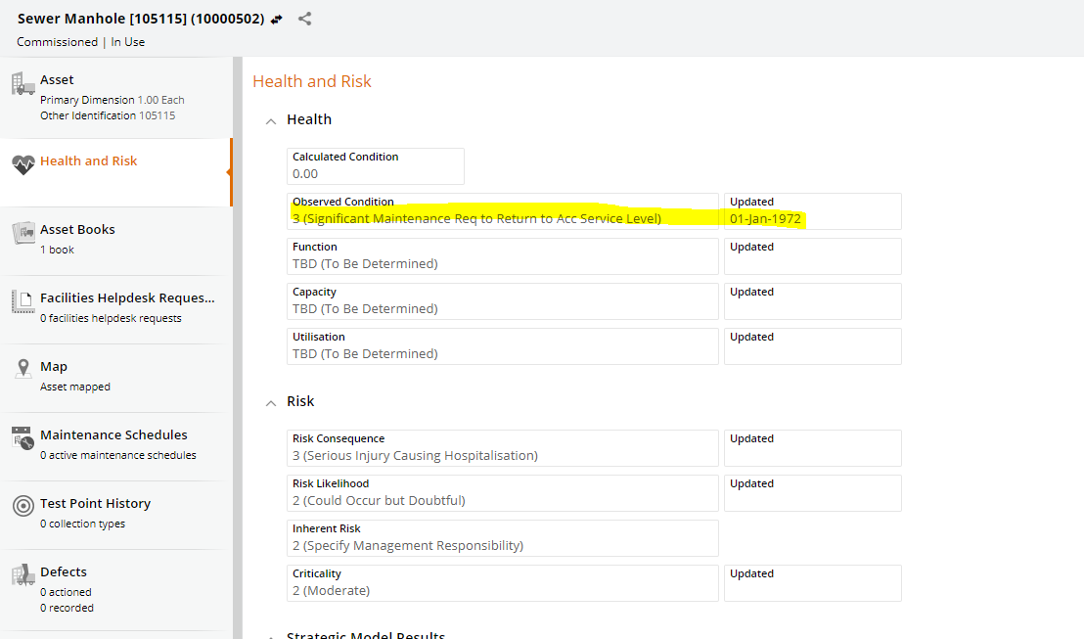

**Tips and tricks:**

**TechOne**

* To filter assets to just a single facility location:
  + Use the filters on the left of TechOne asset screen to filter to Treatment Processing and Bulk Storage asset type. This is the only way for the Parent Asset Number field to able to be added to the table view
  + Use the Search bar to search for the GIS name of the facility in the Details field (e.g. ?Details contains WRWR-WESTERN)
  + Note the asset number of the parent asset
  + Filter on the parent asset number of the parent facility of interest (e.g. ?Parent Asset Number is equal to XXXXXX)
* Some fields do not show up unless you are at the correct hierarchical level in TechOne
  + For example, pipe material and diameter will not appear unless you are filtered down to the Mains/Pipes level of ASSET TYPE

**GIS/TechOne**

* **Do not delete commissioned assets from either database.** If an asset is commissioned and does not exist then change it’s status to REMOVED rather than deleting it. It is OK to delete non commissioned assets but be sure to do it from both GIS and TechOne otherwise the synch will get a little screwy.

**Ideas for Improvement**

* Need some sort of QA checker on GIS data before running the FME GIS Synchronisation tool. Maybe something that checks the values in a feature class against the acceptable domains? Somehow incorrect values are still slipping through.
* A tool that checks the synchronisation of GIS and TechOne. It would be good to be able to confirm that the two datasets truly match. I know that there are assets in TechOne with no basis in GIS still. Maybe the future built-in TechOne synch will help?